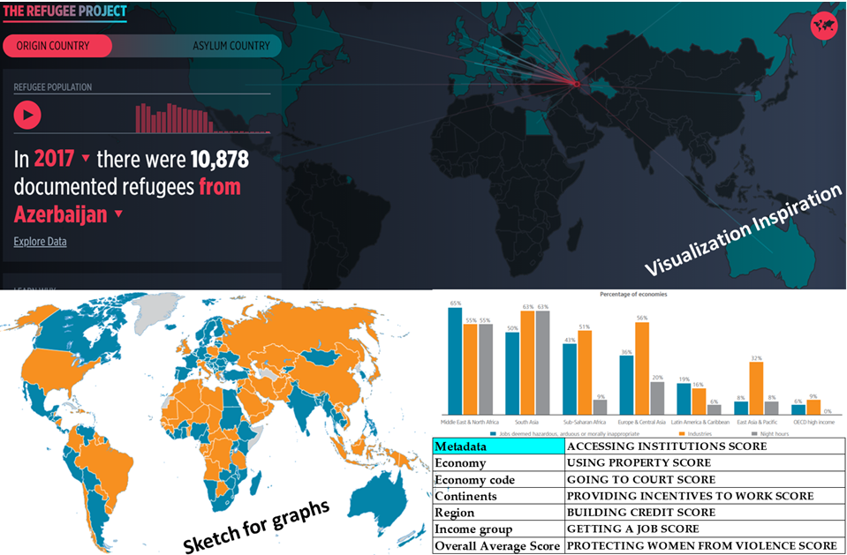

## Women Rights – World Around

This project is an attempt to understand women rights and privileges around the world. The data in this report illustrate women’s economic participation, empowered by the counties legal and social restrictions.

The following general topics have been chosen to draw inferences on how a country equips its women for a greater good:

* Legal right
* Economic stability
* Employment equality
* Judicial protection
* Incentives to work

As part of our project, we will try to highlight the different areas of improvement to make this world a better place for Women. A series of questions documented by the World Bank, provides us information about various countries and their status to women rights.

This has been a continual effort by the World Bank to document the progress over years, they claim – “*Since this research started, the realization of the importance of women’s entrepreneurship and employment has increased significantly, as has our understanding of the relationship between legal gender equality and women’s economic outcomes*”

*Reference:* [*WBL-Key-Findings-Web-FINAL-2*](http://pubdocs.worldbank.org/en/999211524236982958/WBL-Key-Findings-Web-FINAL-2.pdf)

Team Members:

*Karol Consoldane*

*Sophia*

*Ross A Lovelace*

*Sheela Srinivasa*

Data sources:

[*https://datacatalog.worldbank.org/dataset/women-business-and-law*](https://datacatalog.worldbank.org/dataset/women-business-and-law)

*https://en.wikipedia.org/wiki/List_of_countries_by_tax_rates*

[*http://gsociology.icaap.org/dataupload.html*](http://gsociology.icaap.org/dataupload.html)

Github repository:

[*https://github.com/Sheelasrinivasa/UTAustinDataCampProject2*](https://github.com/Sheelasrinivasa/UTAustinDataCampProject2)